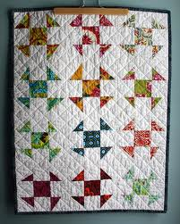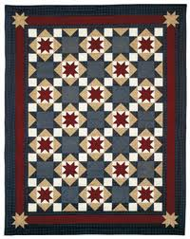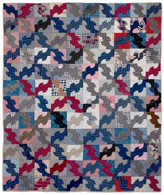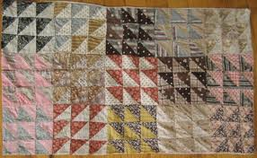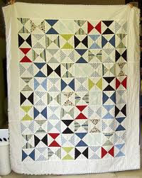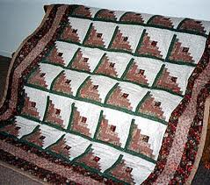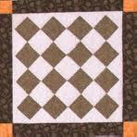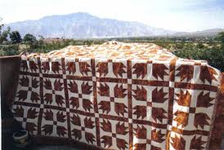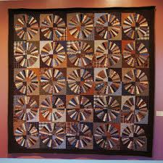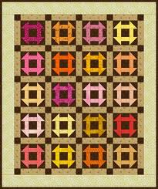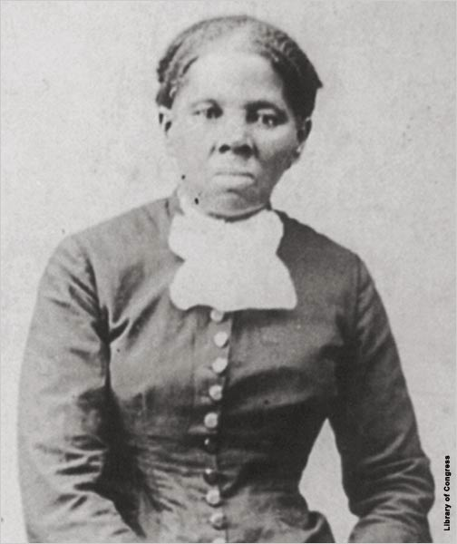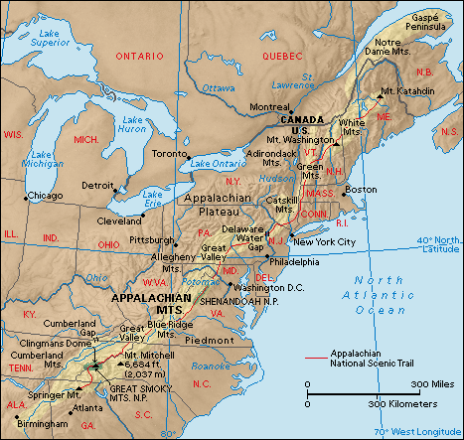

10. The North Star Follow the North Star

9. Drunkard’s Path create a confusing trail

8. Flying Geese Follow migrating birds north

7. Bow Tie Change clothes so you can fit in

5. Log Cabin Indicates a Safe house

4. Crossroads travel to the “crosswords,” or a city where they would find protection and refuge.

3. Bear Claw Follow animal prints to water and food

2. Wagon Wheel Pack like you are loading a wagon

1. Monkey’s Wrench

Collect tools for escape

The Underground Railroad

There are at least 3 children’s books and 1 best selling novel based on the Quilt Code….all lies.

Gimmick to sell quilts and sell lectures and sell quilt patterns and books.

Created to make teaching slavery warm and fuzzy

IT IS A LIE, A QUILT CODE NEVER EXSITED !

6. Shoofly A person who can help

The Underground Railroad is the name for the secret route fugitives took to escape to freedom. It was so named because fugitives who traveled on it just seemed to vanish as if traveling underground.

The Route

Harriet Tubman

The code

Surprising Info

Quilt Code of the Underground Railroad