Ms. Ackerman’s Project Notes Date: 2/12/13

Project Title:

The Underground Railroad and the Quilt Code

Introduction: Definition (What is it?) and short description (give and example) remember to grab the reader’s attention!

Researchers recently learned that an Underground Railroad Quilt Code existed to guide fugitive slaves to freedom on the Underground Railroad. The Underground Railroad was not an actual railroad, but a system of secret passageways, hideouts, and helpers that helped slaves escape to freedom usually in Canada or other free states. Because it was illegal for slaves to be taught to read, slaves used their oral storytelling heritage to create messages in quilts that told a secret story using codes. Sounds like a wonderful story, but was it true?

Question 1: What was the Underground Railroad?
Facts with Source
- Slaves tried to escape from owners. But attempting an escape, or helping someone else to escape, was dangerous and could result in severe punishment or death.
- The Underground Railroad is the name for the secret route fugitives took to escape to freedom. It was so named because fugitives who traveled on it just seemed to vanish as if traveling underground. (Really good Stuff)
- It was, of course, not a real railroad, but rather a series of safe hiding places called “stations.” The people who helped the fugitives travel from one station to the next were known as “railroad workers.” The people who helped fugitives get food and places to sleep were known as “station masters.”
- Harriet Tubman was one of the best-known conductors on the Underground Railroad. After she made her escape from slavery, Tubman returned to the South a total of 19 times to bring over 300 fugitives to freedom. She never lost a single “passenger” (Burns and Bouchard).
- Reaching a station in the North meant food, clothing, and a place to hide when capture was imminent. But it did not yet mean freedom. The Underground Railroad took them all the way to Canada in some cases. Estimates are that as many as 100,000 people escaped slavery between the American Revolution and the Civil War (Burns and Bouchard).
- As part of their secret language, fugitives referred to Cleveland as Hope. Detroit was another “crosswords” referred to as Midnight. Men ready to be delivered to safety were “hardware,” and women were “dry goods” (Burns and Bouchard).
- The main crossroads or terminal was Cleveland, OH. Four or five overland trails connected with Cleveland and numerous waster routes crossing Lake Erie into Canada and freedom. (Burns & Bouchard).
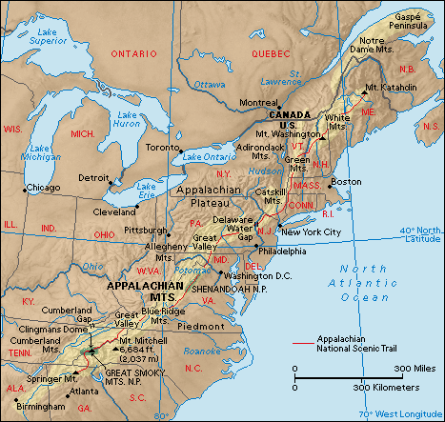
- Sometimes the slaves hid out in churches or caves referred to as cathedrals. Graveyards were frequently the hiding place, especially if they were located on the outskirts of town or were close to rivers. They may have secretly hid behind gravestones waiting for a signal from a lantern across town. (Burns and Bouchard).
- When slaves first escaped, they wore distinguishable clothes that eventually became tattered and tor along their journey. Free blacks would often meet them in a safe place as a church and give them fresh clothing. That way runaways wouldn’t stand out among city folks. On the final leg of their journey, slaves could walk through town undetected to ships waiting to take them across the Great Lakes to Canada and freedom. (Burns and Bouchard).
- Since geese fly north in the spring, it was also the best time for slaves to escape. Geese have to stop at waterways along their journey in order to rest and eat. Especially since geese make loud honking noises, it was easy for runaways to follow their flight pattern. (Burns and Bouchard).
- When the Compromise of 1850 strengthened the Fugitive Slave Act, allowing slaveholders to retrieve slaves in the Northern states and free territories, runaway slaves weren’t safe until they reached Canada. Many depended on ships and ferries to cross icy Lake Erie.

Question 2: What are code quilts?
Facts with Source
- People who worked and traveled on the Railroad used secret codes to learn the routes from one safe place to the next. (Really good stuff)
- Researchers recently learned that an Underground Railroad Quilt Code existed to guide fugitives to freedom. Because it was illegal in slave-holding states to teach slaves to read, slaves could not communicate with each other in writing. But, because slaves of all backgrounds shared an oral history of storytelling coupled with a knowledge of textile production and African art—an art form which embodies African symbolic systems and designs—t h e y discovered they were able to communicate complex messages in the stitches, patterns, designs, colors and fabrics of the American quilt. (Really good stuff)
- To memorize the code, researchers believe fugitives used a sampler quilt, with blocks arranged in order of the code. The patterns told slaves how to get ready to escape, what to do on the trip, and where to go. (Really good stuff)
- Once stitched, the coded quilts were “aired” out the windows of slave cabins, acting as secret maps for slaves brave and desperate enough to make the dangerous trek from South to North, from slavery to freedom. (Really good stuff)
- The Monkey Wrench quilt was the first quilt displayed as a signal for any slaves who planned to escape. This quilt symbolized the time to collect tools they would need on their journey north to freedom. The blacksmith, the most knowledgeable person on the plantation, was known as the “Monkey Wrench.” He had strong, skillful hands, and could talk to the slaves by the rhythmic hitting of the hammer on the anvil. The “monkey wrench” might be loaned out to neighboring plantations, so he knew the lay of the land. This person also familiar with the daily operations of the plantation, would not arouse suspicion. Frederick Douglas, a will know abolitionist, was a free black “monkey wrench”. Found in his home in Cedar Hill, Washington, D. C. was a Monkey Wrench Family Quilt (Burns and Bouchard).
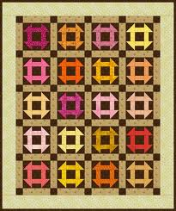

- The Wagon Wheel was the second quilt to be displayed on the fence. Wagons with hidden compartments were one of the primary means of transporting escaping runaways. The quilt was a message to pack provisions for their journey as if they were packing a wagon. The wagon was also symbolic of a “chariot that was to carry them home.” The spirituals they sang carried hidden messages, as “Swing Low Sweet Chariot.” (Burns and Bouchard).
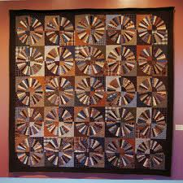

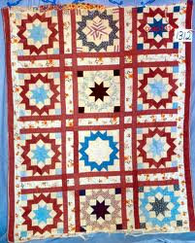
- The Carpenter’s Wheel quilt was a secondary code pattern. To a slave, the master carpenter in their lives was Jesus. As they worked in the fields, they sang this well-known spiritual about a chariot that was to carry them home. Plantation owners thought they were singing about joining Jesus in heaven, but the song held a hidden message. Future runaways recognized this as a directive to plan their escape. They were to follow the Carpenter’s wheel to the west-northwest. (Burns and Bouchard).

- The Bear’s Paw quilt was the third quilt used to help prepare slaves for their journey to freedom. Runaways were directed to follow the actual trail of a bear’s footprints. Animal footprints would indicate the best path, just like a road map, through the mountains. Following the bear’s paws would also lead tired, hungry runaways to food and water. (Burns and Bouchard).
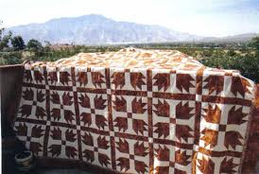

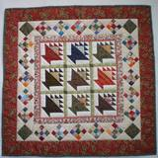
- The Basket Block is a symbol of the provisions needed for the long journey. One of the most difficult things faced by escaping slaves was feeding themselves along the journey. One of the ways the provisions were carried was in a laundry or sewing basket. (Burns and Bouchard).

- The crossroads quilt was the fourth quilt with symbolic meaning revealed to slaves planning to escape. Once fugitives made it safely through the Appalachian Mountains, they were to travel to the “crosswords,” or a city where they would find protection and refuge.
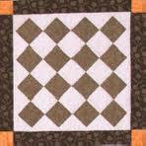

- The log cabin block is the fifth quilt in the secret code. The block may have indicated there was a specific log cabin in Cleveland that was a safe house. It also may have directed runaways to build a log cabin to weather out winter and establish permanent residency in a “free” area. Red center=hearth or fire of a cabin; yellow center indicated a light or beacon in the wilderness. (Burns and Bouchard).
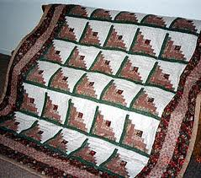

- The shoofly represents an actual person who might have helped escaping slaves. His responsibility was to secretly aid and harbor fugitives. (Burns & Bouchard).
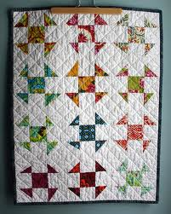

- The Bow Tie quilt was the seventh quilt displayed on the fence to teach slaves how to escape to freedom. It was a directive for them to dress in formal manner. The triangular quadrants on the Bow Tie block indicate morning, midday, evening, and night. It is also known as Broken Dishes. Broken dishes arranged on a gravesite is a superstition among Southern African Americans. When the pattern is turned on its side, an hourglass is created which is a symbol of time well managed. To the African Secret Society the hourglass implies you are among friends. (Burns and Bouchard).
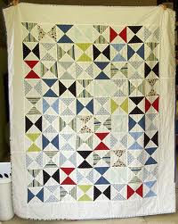

- The Flying Geese quilt is the eighth quilt in the code. With the appearance of this quilt, slaves learned they were to take their direction, timing and behavior from migrating geese. This one block could act as a compass because the quilter could turn one block a specific direction. (Burns and Bouchard).
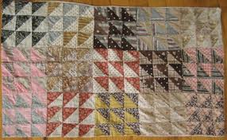

- The Drunkard’s Path quilt is the ninth patter of the secret code. Slaves were to move in a staggering fashion to allude any following slave hunters. They were to even double back occasionally on their tracks to confuse slave catchers who were pursuing them. (Burns and Bouchard).
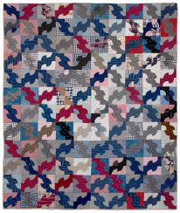

- The sailboat block quilt is a symbol of sale passage to freedom. It also represents the importance of free black sailors to the Underground Railroad.
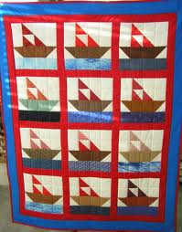

- North Star Quilt is the tenth quilt in the secret code. The North Star was the guiding light leading slaves to Canada and freedom.
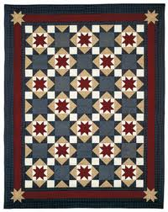

- “The monkey wrench turns the wagon wheel on the bear’s paw trail to the crossroads” (Hidden in Plain View p. 82).
- “Once they got to the crossroads they dug a log cabin on the ground. Shoofly told them to dress up in cotton and satin bow ties…” (Hidden in Plain View p. 96).
- “Flying geese stay on the drunkard’s path and follow the stars” (Hidden in Plain View p. 110).

Question 3: What codes were used in the quilts?
Facts with Source
- Monkey Wrench: This meant that slaves were to gather all the tools they might need on the journey to freedom. Tools meant: something with which to build shelters, compasses for determing direction, or tools to serve as weapons for defending themselves. (Really good stuff; Burns & Bouchard; Stroud)
- Wagon Wheel: This was the second pattern to be displayed, which signaled the slaves to pack all the things that would go in a wagon or that would be used during their journey. This was a signal for the slaves to thing about what essentials they needed to survive the trip. (Really good stuff; Burns & Bouchard; Stroud)

- Carpenter’s Wheel: This pattern would have particular significance to slaves skilled in a craft—such as carpentry. It was also a symbol to “steal away” –a visual equivalent to the popular spiritual “Steal Away”, which many slaves knew and sang. The pattern told slaves to “run with faith” to the west—northwest territories. (Really good stuff; Burns & Bouchard; Stroud)

- Bear’s Paw: It’s believed that this pattern was sometimes used to help fugitives follow the path of the bear, and to identify landmarks on the edge of the plantation. (Really good stuff; Burns & Bouchard; Stroud)

- Crossroads: Once thought the mountains the slaves were to travel to the crossroads. The main crossroad was Cleveland, OH. Any quilt hung before this one would have given directions to Ohio. (Really good stuff; Burns & Bouchard; Stroud)

- Log Cabin: This pattern was used to let the slaves know where safe houses were. People who helped the Underground Railroad may have identified themselves as friends to slaves on the run by tracing this pattern in the dirt as a signal. This quilt told slaves to look for this symbol on their journey to freedom. It was also a symbol to set up a “home” in a free state. (Really good stuff; Burns & Bouchard; Stroud)

- Shoofly: Little is known about this pattern. It is believed that Shoofly refers to an actual person who might have aided escaping slaves. (Really good stuff; Burns & Bouchard; Stroud)

- Bow Ties: Slaves’ clothes were often tattered and easy to spot. This pattern meant that someone would bring the slave nice clothes to help them blend in with the free blacks. (Really good stuff; Burns & Bouchard; Stroud)

- Flying Geese: This pattern told the slaves to follow migrating geese north towards Canada and to freedom. This pattern was used as directions as well as the best season for slaves to escape. Geese fly north in the spring and summer. Flying geese pointed to the dirextion, north, for the slaves to move. Also geese would have to stop at waterways along their journey in order to rest and eat. Slaves were to take their cues on direction, timing and behavior from the migrating geese. (Really good stuff; Burns & Bouchard; Stroud)

- Drunkard’s Path: This was clear warning for the slaves to move in a staggering fashion so as to elude any following slave hunters. It was suggested that slaves even double back to elude their pursuers. (Really good stuff; Burns & Bouchard; Stroud)

- North Star: This instructed the slaves to follow the North Star to Canada and to freedom. (Really good stuff; Burns & Bouchard; Stroud)

- Tumbling Blocks: This signaled to the slaves—by the number of boxes and knots—the time to “box up” all one’s belongings in preparation to escape. (Really good stuff; Burns & Bouchard; Stroud)

- Jacob’s Ladder: This block has an alternating path of dark and light that can be used to show direction.
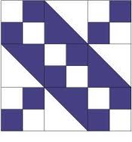

- Basket Block: A symbol of the provisions needed for the long journey.
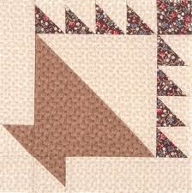

- The Birds in the Air quilt block is symbolic of flight or migration.
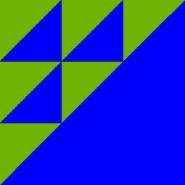

- Sailboat block: A symbol of safe passage to freedom. It also represents the importance of free black sailors to the Underground Railroad.
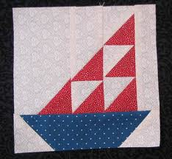

Startling Facts:
- The premise of the "Quilt Code" is that various geometric patterns commonly found in American patchwork quilts were used to convey messages in connection with the Underground Railroad. But even among Code proponents, the patterns’ meanings, how the quilts were used, and who used them is a matter of debate: as of mid-2005 at least 15 contradictory versions of the Code were circulating. Some proponents claim the Code as part of their family oral history, but none can point to an ancestor who used it to escape to the North or even participated in the Underground Railroad (Fellner; Ives; Stukin).
- Firsthand accounts of fugitive slaves and Underground Railroad participants detail many ways of conveying messages but never mention using quilts, and the details of the Code are incompatible with documented evidence of the Underground Railroad, slave living conditions, quiltmaking, and African culture. For example, the Code includes quilt patterns known to have originated in the 1930s, and while Code proponents say certain patterns are derived from African symbols, the messages the Code assigns to them conflict with the meanings the symbols have in Africa (Fellner; Ives; Stukin).
- Along with many other myths involving quilts and subcultures (such as the Amish), the Code materialized in the 1980s during the post-Bicentennial revival of folk art, the popularization of women’s history studies, and Western notions of African culture comparable to early Hollywood depictions of Native Americans. The earliest mention of a "quilt code" is a brief statement in a 1987 feminist video: quilts were hung outside Underground Railroad safe houses. (No source is given for the assertion and it is conspicuously absent from the companion book.) In 1993 a white Massachusetts woman elaborated on the Code idea in Sweet Clara and the Freedom Quilt, a children’s fiction book; its heroine makes a quilt containing a topographical map she uses to escape from slavery (Fellner; Ives; Stukin).
- Not long after Sweet Clara was published, Ozella Williams, a retired California school administrator, used her own version of a "quilt code" to sell quilts in a Charleston, South Carolina tourist mall. One of her customers was Jacqueline Tobin, a white instructor in "women’s words," who unsuccessfully pressed Williams for details. When Williams refused to return Tobin’s phone calls, Tobin visited Williams unannounced and "coaxed" the elderly woman to reveal the Code to her. The resulting book, Hidden In Plain View, was published after Williams's death, and was promoted by Oprah Winfrey and quilt shop owners, who produced Code quilt kits for the multibillion-dollar quilters market, and by antique dealers who used the Code as a marketing tool. Williams’s family members developed a cottage industry lecturing on the Code and selling related merchandise. Although no historian has ever supported the Code, by 2001 elementary and secondary schools were teaching it as historical fact. But after scholars pointed out numerous discrepancies between the Code and documented Underground Railroad history, earlier supporters of the Code began distancing themselves from its claims. Tobin herself has since complained that "people have tried to push the book in directions that it was not meant for," and when Dobard was asked in 2009 where his book should appear on library shelves, he said "somewhere between fact and fiction." (Fellner; Ives; Stukin).
- by dressing the story up all cute and pretty with quilt patterns and kindly folks who used them to guide runaways to freedom - then we don't have to talk about the realities of slavery, and of running away, etc. It seems to me to be part and parcel of the continued erasure of African American history - by creating mythical stories the truth is eventually lost. No one needs myths as a substitute for history, nor as a way to explain the complications of history. There is plenty of the real stuff out there, waiting to be exposed and taught to everyone (Fellner).
- What we should be teaching adults and children is the truth, and specifically, that slaves didn't use quilt patterns - they used their own wits and bodies to fight their way to freedom (Larson).

Conclusion: Restate you main points or 3 questions in statement form. This is your last chance to tell your readers why your research is important.

The Underground Railroad is a powerful element in our trouble American past with slavery. Harriet Tubman and the many others who risked their lives so 100,000 or more slaves could live free in the North and Canada is vital to our history. Unfortunately, the myth of the Quilt Code is persistent in our collective story telling and has become fact. by dressing the story up all cute and pretty with quilt patterns and kindly folks who used them to guide runaways to freedom - then we don't have to talk about the realities of slavery, and of running away, etc. It seems to me to be part and parcel of the continued erasure of African American history - by creating mythical stories the truth is eventually lost. No one needs myths as a substitute for history, nor as a way to explain the complications of history. There is plenty of the real stuff out there, waiting to be exposed and taught to everyone (Fellner). What we should be teaching adults and children is the truth, and specifically, that slaves didn't use quilt patterns - they used their own wits and bodies to fight their way to freedom (Larson).

Working Bibliography: Using Easybib.com, create an ongoing list of every site you visit and every book you use. You need to have a minimum of six resources.

Works Cited
"African American Quilting Traditions." African American Quilting Traditions. University of Virginia, 2013. Web. 12 Feb. 2013. <http://xroads.virginia.edu/~ug97/quilt/atrads.html>.
America the Story of Us: Harriet Tubman and the Underground Railroad. Perf. Liev Schreiber. The History Channel, 2010. DVD. The History Channel America the Story of Us: Harriet Tubman and the Underground Railroad. The History Channel, 2013. Web. 12 Feb. 2013. <http://www.history.com/shows/america-the-story-of-us/videos/harriet-tubman-and-the-underground-railroad#harriet-tubman-and-the-underground-railroad>.
Appalachian Mountains. Digital image. Explorations. N.p., 2013. Web. 16 Feb. 2013. <http://tcdsbstaff.ednet.ns.ca/asaulnier/Atlantic%20Canada%20Studies%209/Explorations%20Answers%20p%2025%2026.html>.
Burns, Eleanor, and Sue Bouchard. Underground Railroad Sampler. San Marcos, CA: Quilt in a Day, 2003. Print.
Fellner, Leigh. "Quilt History." Quilt History. Hart Cottage Quilts, 2013. Web. 12 Feb. 2013. <http://www.ugrrquilt.hartcottagequilts.com/>.
Hopkinson, Deborah, and James Ransome. Under the Quilt of Night. New York: Aladdin Paperbacks, 2005. Print.
Ives, Sarah. "Did Quilts Hold Codes to the Underground Railroad?" National Geographic. National Geographic Society, 5 Feb. 2004. Web. 12 Feb. 2013. <http://news.nationalgeographic.com/news/2004/02/0205_040205_slavequilts.html>.
Larson, Kate Clifford. "Re: Question??? Who Used & How Were Quilts Used?" Re: Question??? Who Used & How Were Quilts Used? N.p., 13 July 2004. Web. 25 Feb. 2013. <http://www.afrigeneas.com/forum-ugrr/index.cgi/md/read/id/278>.
Stroud, Bettye, and Erin Susanne Bennett. The Patchwork Path: A Quilt Map to Freedom. Cambridge, MA: Candlewick, 2007. Print.
Stukin, Stacie. "Unraveling the Myth of Quilts and the Underground Railroad." Time. Time, 3 Apr. 2007. Web. 12 Feb. 2013. <http://www.time.com/time/arts/article/0,8599,1606271,00.html#ixzz2Kild65OK>.
"Underground Railroad: A Path to Freedom." Underground Railroad: A Path to Freedom. Eastern Illinois University, 20 Oct. 2008. Web. 16 Feb. 2013. <http://eiu.edu/eiutps/underground_railroad.php>.
"Underground Railroad Quilt Guide." Really Good Stuff. Really Good Stuff, 2005. Web. 12 Feb. 2013. <http://page.reallygoodstuff.com/pdfs/154227.pdf>.
"The Underground Railroad Slideshow | Underground Railroad Student Activity | Scholastic.com." The Underground Railroad Slideshow | Underground Railroad Student Activity | Scholastic.com. Scholastic, 2013. Web. 12 Feb. 2013.

